
Activity 3.1.6 Commercial Floor Systems

Introduction
Commercial floors must typically withstand greater loads and heavier traffic than residential floors and are therefore often built with different components. Concrete is a common floor material for commercial structures. In this activity you will research two potential elevated concrete floor systems for the Keystone Library Project and perform preliminary designs for each system. As you complete the activity, notice the similarities and differences in materials and sizes in the two floor systems.

Equipment
- Engineering notebook
- Pencil
- Printer
- Keystone 2nd Floor Framing Hollow Core Precast
- Keystone 2nd Floor Framing Composite Slab
- Composite Floor Deck Load-Span Table
- Hollow Core 8 Load-Span Table
- Keystone Library Renovation Preliminary Building (student version).rvt as altered by student

Procedure
In order to create a second level for the Keystone Building, a new elevated floor system will replace the existing roof. Assume that the roof framing must be replaced because the new floor loads will be much greater than the existing roof loads. Two floor systems will be investigated for potential use as the second floor in the Keystone Library – cast-in-place concrete on metal deck (composite slab design) and precast hollow core concrete panels.

- Research each of the floor systems for use as an elevated floor in the Keystone Building.
- Label the components of each system in the detail of the floor at the structural steel beam.
- For each system, use the appropriate load-span table to select the most economical floor design to support the proposed superimposed floor load of 150 psf. Note the specifications for each floor.
- Use a highlighter to indicate the selected design on each table.
- Give the specifications for the slab as indicated.
FLOOR TYPE | SKETCH | Specification
Composite Slab Design (cast-in-place concrete on metal decking) | 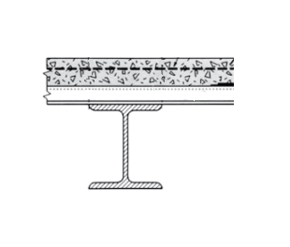 | - Normal Weight Concrete  - Type 1.5 CF Composite Floor Deck  - 3-span  - ________span length  - ________ slab thk.  - ________ deck Type  - ________ WWF  - ________ allowable unshored clear span
Hollow core precast concrete floor panels | 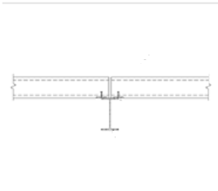 | - ________span length  - ________ panel width  - ________ slab thk.  - ________ No. & size of reinforcing strands

- Which flooring system would you recommend for the Keystone Library? Justify your choice.

- Model the composite floor design specified above in your 3D architectural model. For now use the same floor design to support your green roof, that is, use the selected floor as the base layer for your green roof design.

Conclusion
- Explain why the materials used in a residential floor system are different from a commercial system.

- Describe the advantages of using precast concrete floor components.

- When comparing two different concrete flooring systems (such as precast panels and cast-in-place slabs), what factors would you consider as you choose a system for a building design?

4. Describe how engineers can change the strength of a concrete floor so that it can carry a heavier load.

